Meeting Week 02

| Location: | 14 Sir Christopher Ondaatje Ave Room 163 |
| --- | --- |
| Date: | 02/08/2023 |
| Time: | 11:00 am to 1:00 pm |
| Attendees: | 48038679 Deepanshu Chandna, 44379455 Yuchen Yang, 47905085 Hasanul Banna  47765305 Shweta Hooda, 47901306 Jacqueline Dela Rosa, 46139206 Guangye Li  48089133 Md Shimul Hossain |

# Agenda items

1. Discuss and finalize each member’s position in the company.
2. Discuss the set-up of the company (whether it needs to be changed).
3. Brainstorm related security frameworks and standards

| Action items | Owner(s) | Deadline | Status |
| --- | --- | --- | --- |
| Research of frameworks | All members | 06/08/2023 | In progress |
| Finalization of Company | Hasanul Banna | 06/08/2023 | In progress |
|  |  |  |  |

Meeting Week 03

| Location: | 14 Sir Christopher Ondaatje Ave Room 163 |
| --- | --- |
| Date: | 09/08/2023 |
| Time: | 11:00 am to 1:00 pm |
| Attendees: | 48038679 Deepanshu Chandna, 44379455 Yuchen Yang, 47905085 Hasanul Banna  46139206 Guangye Li |

# Agenda items

1. Read through the two support documents on ilearn.
2. Finalize the set-up of our company.
3. Discuss the basics and scope of ISMS for our company.

| Action items | Owner(s) | Deadline | Status |
| --- | --- | --- | --- |
| Finalization of Company | Hasanul Banna | 06/08/2023 | Done |
| Create a scope statement | All members | 13/08/2023 | To do |

Meeting Week 03

| Location: | Zoom Online Meeting |
| --- | --- |
| Date: | 09/08/2023 |
| Time: | 3:00 mm to 3:30 pm |
| Attendees: | 48038679 Deepanshu Chandna, 44379455 Yuchen Yang, 47905085 Hasanul Banna  47901306 Jacqueline Dela Rosa, 46139206 Guangye Li, 48089133 Md Shimul Hossain |

# Agenda items

1. Continue the discussion from previous workshop with all the group members.
2. Assign responsibilities to each one in the group.

| Action items | Owner(s) | Deadline | Status |
| --- | --- | --- | --- |
| Create scope statement | All members | 13/08/2023 | In progress |
| Document the basics of ISMS | All members | 13/08/2023 | To do |

Meeting Week 04

| Location: | 14 Sir Christopher Ondaatje Ave Room 163 |
| --- | --- |
| Date: | 16/08/2023 |
| Time: | 11:00 am to 1:00 pm |
| Attendees: | 48038679 Deepanshu Chandna, 44379455 Yuchen Yang, 47905085 Hasanul Banna  47765305 Shweta Hooda, 47901306 Jacqueline Dela Rosa, 46139206 Guangye Li  48089133 Md Shimul Hossain |

# Agenda items

1. Finalize the scope statement for the company.
2. Review what we learned of risk assessment from lecture.
3. Discuss how to approach this week’s workshop (WWMD Table, Consequence Table and information assets)
4. Assign responsibilities to everyone in the group.

| Action items | Owner(s) | Deadline | Status |
| --- | --- | --- | --- |
| Scope statement finalization | All members | 16/08/2023 | Done |
| Lecture review | All members | 16/08/2023 | Done |
| Create WWMD Table | Guangye Li | 20/08/2023 | To do |
| Create Consequence Table | All members | 20/08/2023 | To do |
| Create Information assets list | All members | 20/08/2023 | To do |

Meeting Week 05

| Location: | 14 Sir Christopher Ondaatje Ave Room 163 |
| --- | --- |
| Date: | 23/08/2023 |
| Time: | 11:00 am to 1:00 pm |
| Attendees: | 48038679 Deepanshu Chandna, 44379455 Yuchen Yang, 47905085 Hasanul Banna  47765305 Shweta Hooda, 47901306 Jacqueline Dela Rosa  48089133 Md Shimul Hossain, 46139206 Guangye Li |

# Agenda items

1. Discuss the information assets list created last week (identification of the owners of the information assets).
2. Finalize WWMD and Consequence table.
3. Week 5 workshop document review.
4. Assign responsibilities to everyone in the group.

| Action items | Owner(s) | Deadline | Status |
| --- | --- | --- | --- |
| Information Assets List Update | All members | 27/08/2023 | In progress |
| Create Risk Scenario analysis | All members | 27/08/2023 | To do |

Meeting Week 06

| Location: | 14 Sir Christopher Ondaatje Ave Room 163 |
| --- | --- |
| Date: | 20/08/2023 |
| Time: | 11:00 am to 1:00 pm |
| Attendees: | 48038679 Deepanshu Chandna, 44379455 Yuchen Yang, 47905085 Hasanul Banna  47765305 Shweta Hooda, 47901306 Jacqueline Dela Rosa  46139206 Guangye Li |

# Agenda items

1. Systematic review of existing documents
2. Discuss missing components indicated by mandatory requirements for certification.
3. Week 6 workshop document review.
4. Assign responsibilities to everyone in the group.

| Action items | Owner(s) | Deadline | Status |
| --- | --- | --- | --- |
| Creation of Risk Management Document | Guangye Li, Deepanshu Chandna | 03/09/2023 | To do |
| Finalization of support documents | Guangye Li | 03/09/2023 | In progress |
| Company info document | Hasanul Banna | 03/09/2023 | In progress |
| Information Security Document | Shweta Hooda, Yuchen Yang | 03/09/2023 | To do |
| Operational documents | Jacqueline Dela Rosa | 03/09/2023 | To do |

Meeting Week 07

| Location: | 14 Sir Christopher Ondaatje Ave Room 163 |
| --- | --- |
| Date: | 06/09/2023 |
| Time: | 11:00 am to 1:00 pm |
| Attendees: | 48038679 Deepanshu Chandna, 44379455 Yuchen Yang, 47905085 Hasanul Banna  47765305 Shweta Hooda, 47901306 Jacqueline Dela Rosa  48089133 Md Shimul Hossain, 46139206 Guangye Li |

# Agenda items

1. Finalize prepared documents for working papers review.
2. Week 7 workshop document review.
3. Discuss the possibilities of risk assessment tables redesign.
4. Assign responsibilities to everyone in the group.

| Action items | Owner(s) | Deadline | Status |
| --- | --- | --- | --- |
| Risk Assessment Documents update | Guangye Li | 09/092023 | In progress |
| Add Threats and controls | All members | 09/092023 | To do |
| Company information and business model document | Hasanul Banna | 09/092023 | In proress |
| Security document final checking and update | Yuchen Yang | 09/092023 | To do |

Meeting Week 08

| Location: | WhatsApp group chat |
| --- | --- |
| Date: | 27/09/2023 |
| Time: | 11:00 am to 1:00 pm |
| Attendees: | 48038679 Deepanshu Chandna, 44379455 Yuchen Yang, 47905085 Hasanul Banna  47765305 Shweta Hooda, 47901306 Jacqueline Dela Rosa  48089133 Md Shimul Hossain, 46139206 Guangye Li |

# Agenda items

1. Transition to WhatsApp Group Communication: Due to unforeseen circumstances leading to this week's workshop cancellation, our discussions shift to WhatsApp group. This will ensure continuity in our discussions.
2. The group deliberated on innovative methodologies and approaches to enhance the accuracy of loss calculations associated with the critical information assets' risk scenarios. This discussion explored both quantitative and qualitative assessment techniques.
3. OpenFair Risk Analytics Tool Exploration: A deep dive into the functionalities and capabilities of the OpenFair risk analytics tool, which was a highlight of our recent lecture. The discussion aimed to understand its potential benefits, applicability, and how it could be integrated into our current risk assessment framework.
4. Review of Pending Tasks: We devoted time to a comprehensive review of tasks and discussions that remain incomplete or pending from previous workshops. The aim was to prioritize these tasks, allocate responsibilities where necessary, and set clear timelines for completion to ensure we stay on track with our overarching objectives.

| Action items | Owner(s) | Deadline | Status |
| --- | --- | --- | --- |
| Integrate OpenFair risk analytics tool | All members | 01/10/2023 | To do |
| Create a comprehensive list of all tasks left unfinished from past workshops. | All members | 01/102023 | To do |

# Relevant Supporting Materials

The following are some of the screenshots from WhatsApp group chat.

Meeting Week 09

| Location: | 14 Sir Christopher Ondaatje Ave Room 163 |
| --- | --- |
| Date: | 04/10/2023 |
| Time: | 11:00 am to 1:00 pm |
| Attendees: | 48038679 Deepanshu Chandna, 44379455 Yuchen Yang,  47905085 Hasanul Banna, 48089133 Md Shimul Hossain, 47901306 Jacqueline Dela Rosa  , 46139206 Guangye Li |

# Agenda items

1. Systematic Review of Comments on Our Existing ISMS from Internal Audits:
   1. Overview of the most recurrent comments and areas of concern identified during the internal audits.
   2. Evaluation of the current state of our ISMS in light of these comments.
   3. Recommendations on addressing identified gaps and weaknesses in the ISMS.
2. Discussion on Core Documents Needed for Final External Assessment of our ISMS:
   1. Review of mandatory documents required for the final external assessment.
   2. Identification of additional documents that could strengthen our ISMS presentation.
   3. Timeline for the preparation and finalization of these documents.
3. Engagement with Our Internal Auditor Regarding Openfair Risk Analytics Tool:
   1. Interactive Q&A session to clarify confusions and gain insights on best practices with the tool.
4. Discussion on Business Impact Analysis (BIA) and Creation of Business Continuity Plan Document:
   1. Presentation of the BIA for critical information assets, highlighting potential threats and vulnerabilities.
   2. Review of the drafted business continuity plan document, discussing its effectiveness in mitigating identified risks.
   3. Link BIA and BCP document back to TRA table.

| Action items | Owner(s) | Deadline | Status |
| --- | --- | --- | --- |
| Identify and fix gaps in the existing ISMS | All members | 27/10/2023 | In progress |
| Finalize Loss Calculations using OpenFair risk analytics tool | All members | 07/10/2023 | In progress |
| Conduct BIA | All members | 08/10/2023 | To do |
| Create BCP document | All members | 08/10/2023 | To do |

# Relevant Supporting Materials

Allocation of tasks

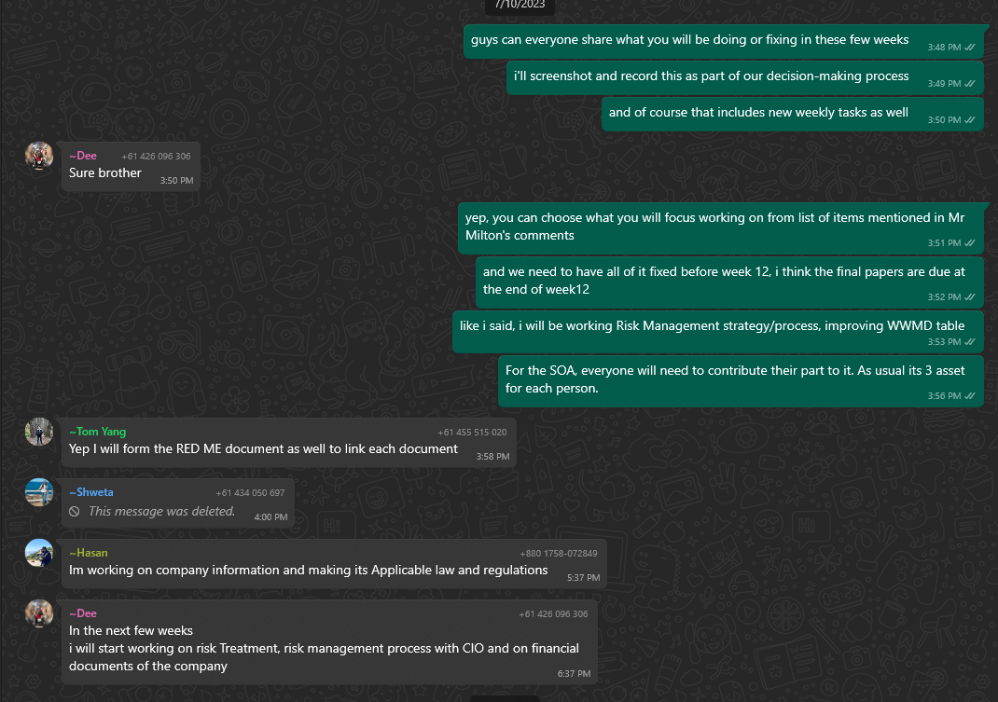

Creation of BIA and BCP document

Meeting Week 10

| Location: | Zoom Online Meeting |
| --- | --- |
| Date: | 11/10/2023 |
| Time: | 4:00 pm to 5:00 pm |
| Attendees: | 48038679 Deepanshu Chandna, 44379455 Yuchen Yang, 47905085 Hasanul Banna  47765305 Shweta Hooda, 47901306 Jacqueline Dela Rosa  48089133 Md Shimul Hossain, 46139206 Guangye Li |

# Agenda items

1. Transition to Zoom Meeting due to Absent Members:
   1. Detailed Discussion: Review the challenges faced by team members in attending physical workshops.
2. Progress Update on Improving our ISMS:
   1. Individual Progress Reports: Each member to briefly discuss the part of the ISMS they've been working on, the challenges faced, and milestones achieved.
3. Q&A Session with CIO Guangye Li:
   1. Pre-Session Preparation: Members should prepare and submit questions beforehand to make the session more structured and efficient.
   2. Insights from Guangye Li: The CIO can offer some insights or share experiences related to ISMS, shedding light on areas that might be challenging or unclear.
4. Discussion on Information Classification Following this Week's Lecture:
   1. Classification Overview: A brief review of the main points from the lecture to ensure everyone's on the same page.
   2. Asset-Based Discussion: Explore each critical information asset and discuss its possible classification. Discuss the potential risks associated with each level of classification.
   3. Labelling Proposals: Based on the classifications, suggest specific labels that would make it easy for any team member to quickly understand the sensitivity and handling requirements of a particular piece of information.

| Action items | Owner(s) | Deadline | Status |
| --- | --- | --- | --- |
| Continue to improve our existing ISMS | All members | 27/10/2023 | In progress |
| Prepare READ Document | Yuchen Yang | 27/10/2023 | To do |
| Creation of information classification policy | All members | 15/10/2023 | To do |
| Classify information assets | All members | 15/10/2023 | To do |

# Relevant Supporting Materials

Discussion on existing ISMS documents and creating information classification policy.

Zoom meeting screenshot:

A brief meeting minute summarization by COO Jacqueline Dela Rosa

The follow up discussions between COO AND CIO Guangye Li

There were some disagreements between COO and CIO on how the group should approach ISMS operational planning and control document. The disagreements were resolved by consulting our internal auditor Mr. Milton.

Meeting Week 11

| Location: | 14 Sir Christopher Ondaatje Ave Room 163 |
| --- | --- |
| Date: | 18/10/2023 |
| Time: | 11:00 am to 1:00 pm |
| Attendees: | 48038679 Deepanshu Chandna, 44379455 Yuchen Yang,  47905085 Hasanul Banna, 47901306 Jacqueline Dela Rosa  , 46139206 Guangye Li, 48089133 Md Shimul Hossain |

# Agenda items

1. Update ISMS Progress and Check Each Member’s Assigned Document:
   1. Quick recap of where we left off in the last meeting.
   2. Each member presents a brief summary of their progress on the assigned ISMS document, detailing the areas completed, challenges faced, and assistance required.
2. Discuss How to Improve Foodie’s ISMS Operational Planning and Control:
   1. Presentation on the current state of ISMS operational planning, its strengths, and areas of improvement.
   2. Outline a roadmap for the implementation of the proposed improvements
3. Discuss Video Presentation of Foodie’s ISMS and its Schedule:
   1. Presentation of the draft storyboard or outline for the video.
4. Discuss How to Improve ISMS Risk Treatment Plan:
   1. Review the existing risk treatment strategies and their effectiveness based on potential incidents.
   2. Evaluate the feasibility and effectiveness of proposed treatment options in the context of Foodie's operations.
   3. Assign responsibilities for the implementation and monitoring of these treatment actions.

| Action items | Owner(s) | Deadline | Status |
| --- | --- | --- | --- |
| Continue to improve our existing ISMS | All members | 27/10/2023 | In progress |
| Improve Foodie’s ISMS Operational Planning and Control | Jacqueline Dela Rosa/Guangye Li | 20/10/2023 | To do |
| Improve Risk Treatment Plan | Deepanshu Chandna | 20/10/2023 | To do |
| Prepare Video Presentation | All members | 27/10/2023 | To do |

# Relevant Supporting Materials

Discussions continued on whatsapp group chat:

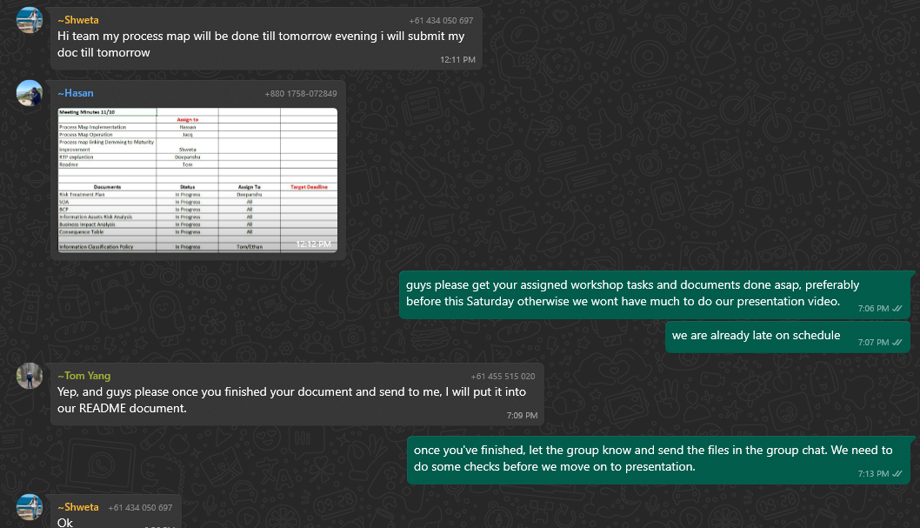

Risk Treatment plan:

